**SHRI B.V.V SANGHA’S**

**BASAVESHWAR ENGINEERING COLLEGE (AUTONOMOUS),**

**BAGALKOT-587102**



**2016-2017**

**DEPARTMENT OF INFORMATION SCIENCE AND ENGINEERING**

**A MINI-PROJECT REPORT ON**

**ONLINE TEST SIMULATION**

**PROJECT GUIDE HOD**

**PROF. G.M.PATIL Dr. SADHANA P.BANGARSHETTI**

**SHRI B.V.V.SANGHA’S**

**BASAVESHWAR ENGINEERING COLLEGE (AUTONOMOUS)**

**BAGALKOT**



**2015-2016**

**DEPARTMENT OF INFORMATION SCIENCE AND ENGINEERING**

**CERTIFICATE**

This is to certify that the mini-project work, entitled “ONLINE TEST SIMULATION” is an bonafide work carried out by the group for the group work specified for the “WEB PROGRAMMING LABORATORY “ as per all the prescribed required for certificated of VI semester during the period of 2016-2017 successfully.

**PROJECT ASSOCIATES**

SUSHMA S ANKAD 2BA14IS056

POOJA M SALUNKE 2BA14IS034

BASAVARAJ REVANAKI 2BA14IS013

**ACKNOWLEDGEMENT**

The sense of contentment and elation that accompanies the successful completion of this group task would be incomplete without mentioning the names of those people who helped us, in accomplishing this group task, people whose constant guidance, support and encouragement resulted in this realization. We are highly indebted to them.

We express our sincere gratitude to our principle Dr. R.N.Herkal who has been the source of motivation for our group task work. We would like to thank Dr. S.P.Bangarashetti, HOD for providing the inspiration required for taking to its completion.

We thank our guide Prof. G.M.Patil for valuable guidance that helped us in completing our group task successfully.

Finally, we would like to express our appreciation to our well wishers, family and friends for their support and much needed encouragement.

**CONTENTS**

1. ABSTRACT
2. INTRODUCTION
3. PROJECT FLOW
4. SOURCE CODE
5. CONCLUSION
6. REFERRENCES

**ABSTRACT**

This report will provide detailed account of the processes our group used to design and implement a website that can be used to simulate the “ONLINE TEST”. The “ONLINE TEST SIMULATION” simulate the online test conduction which is very necessary in attending the online competitive exams. The website validates the user before candidate appearing for the examination.

**INTRODUCTION**

The name of the website is “TEST SIMULE”, which simulates the online test. The candidate who willing to appear for the test should register their names before they attend the test. They should log in before taking test. The candidates will submit their details like name, semester, USN and branch accordingly. The semester and USN are validated while registering and log in. If the registration of candidate is successful, he/she should log in to take test. If the login get failed, then they are redirected back to the home page.

On successful log in, the next page with set of questions are displayed on the screen. This current page contains the set of multiple choice questions with 4 answers each. After taking this test, they have to on click the button ‘submit’ at the bottom. Then the evaluated marks are displayed on the next page.

FLOW OF TEST SIMULE

Questions Page

Display of marks

Is login

Succeeds?

Login failed

Login

Registration Successful

Registration Failed

Is registration succeeds?

Registration

Yes

No

Yes

No

Home page:

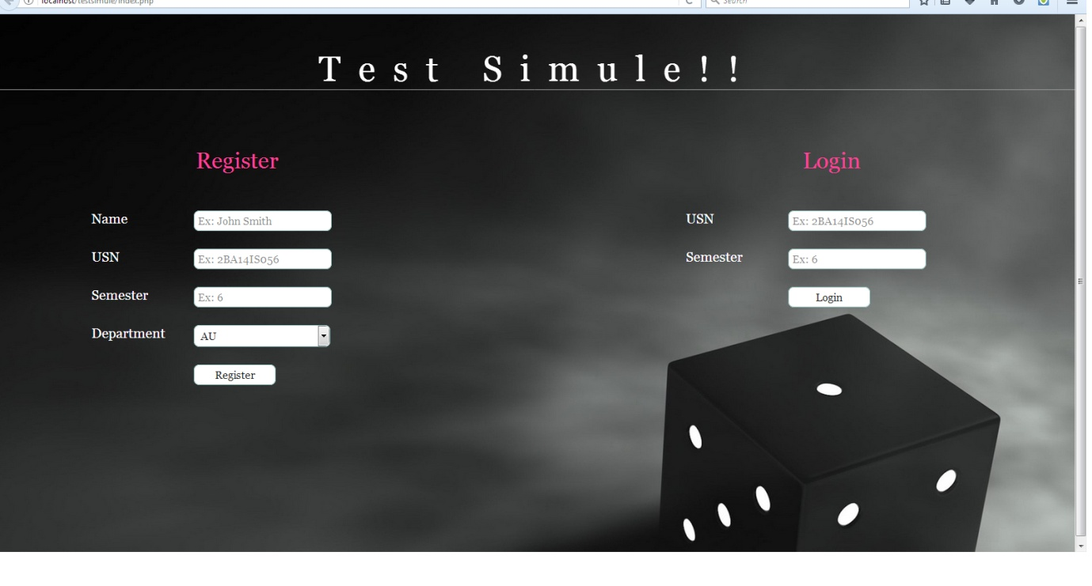

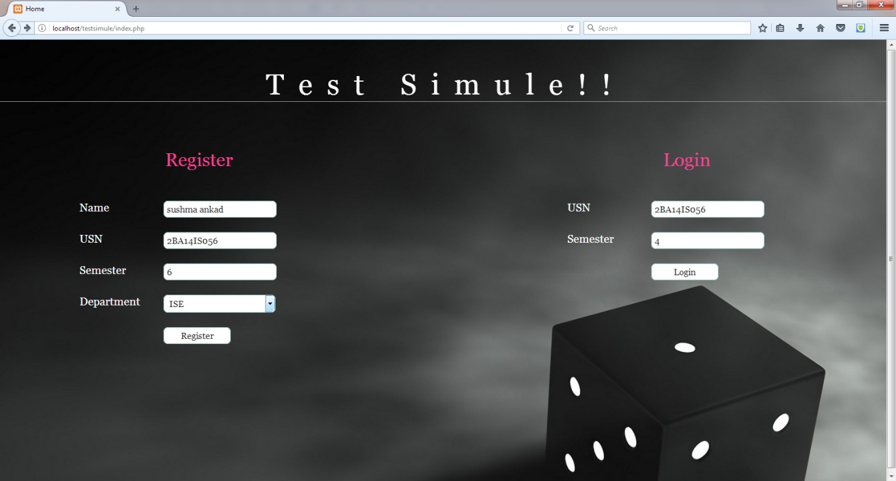

On Registration Successful:

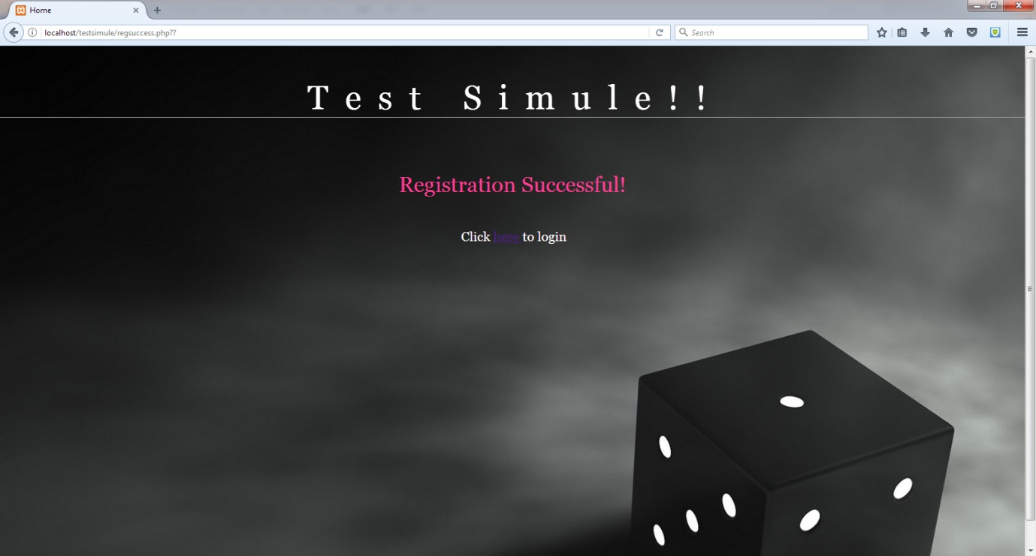

Redirecting to homepage to log in: 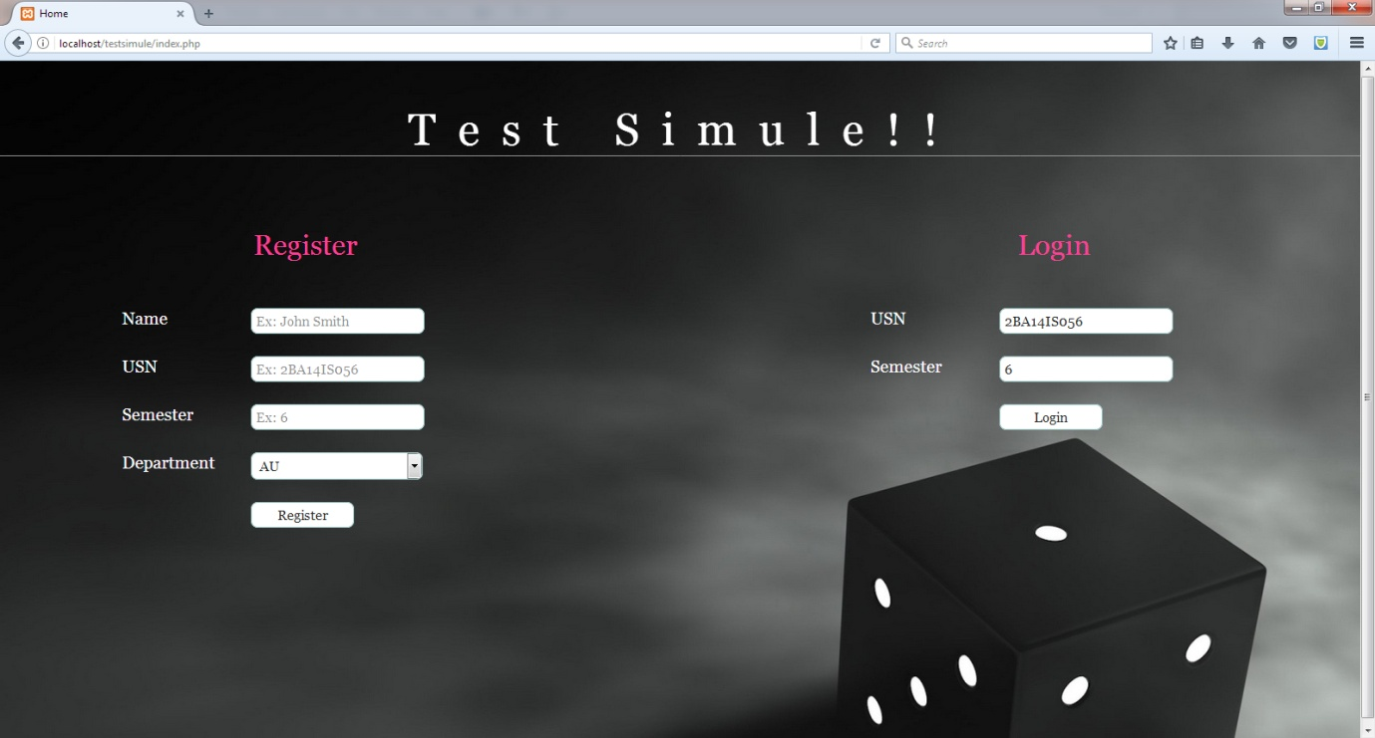

Log in success:

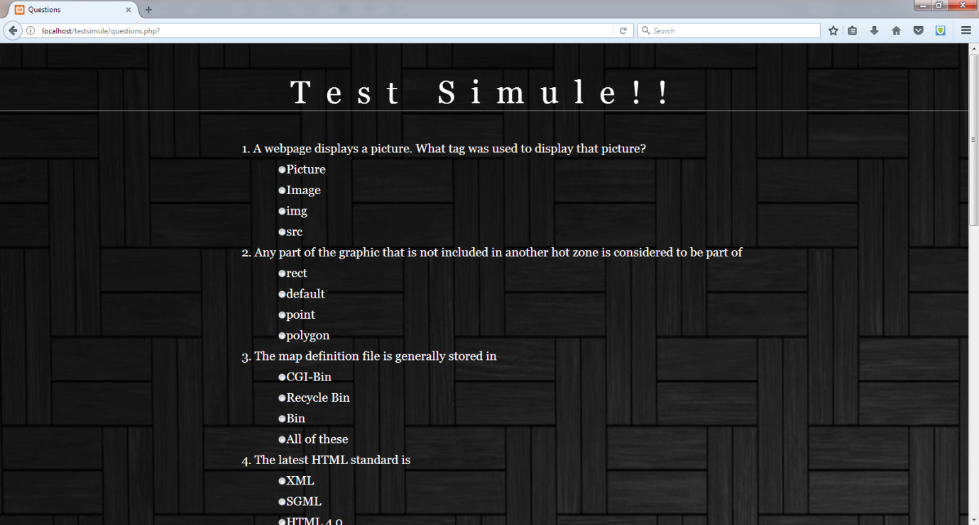

Log in failed:

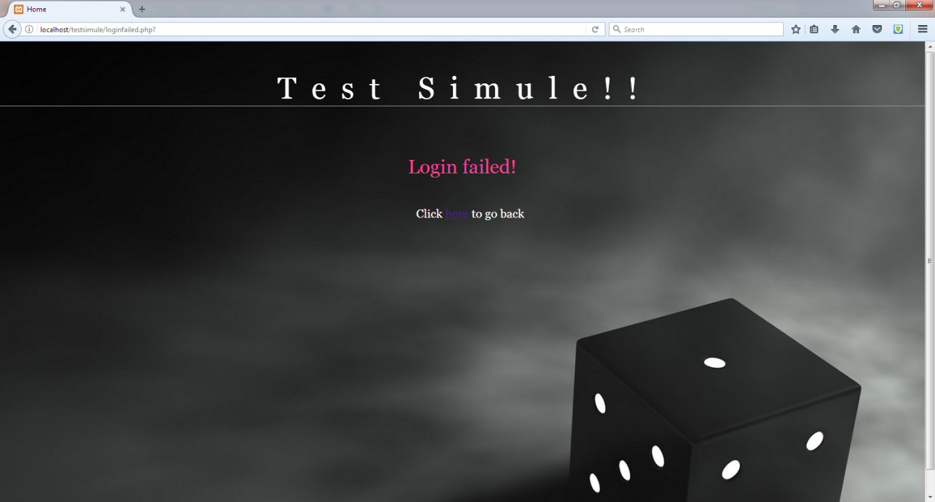

Result after submitting answers:

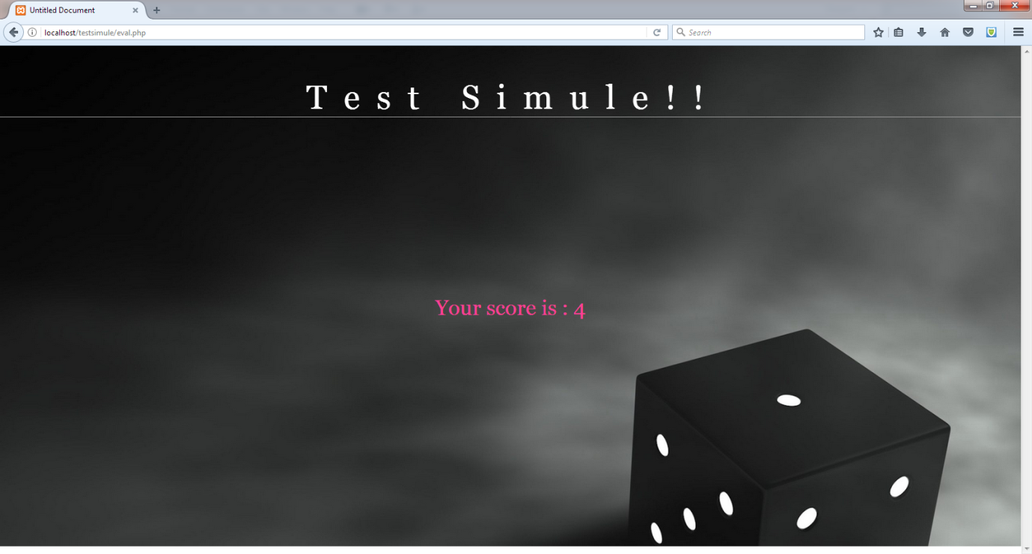

**Backend Databases:**

**User table:**

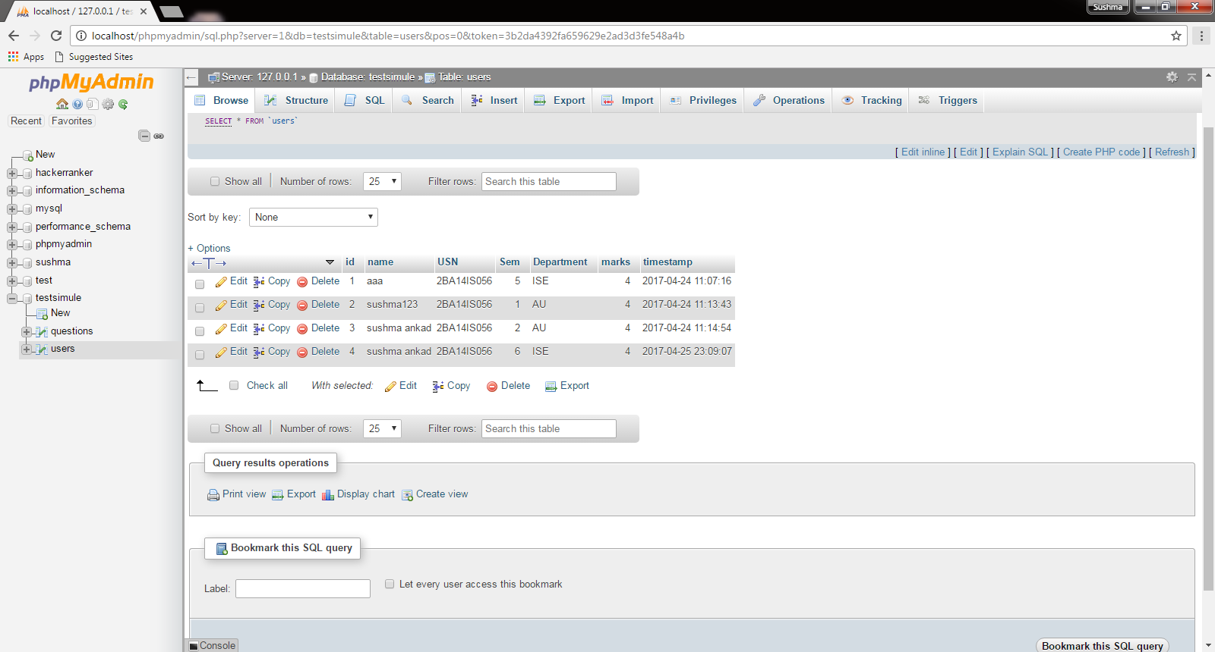

**Question Table:**

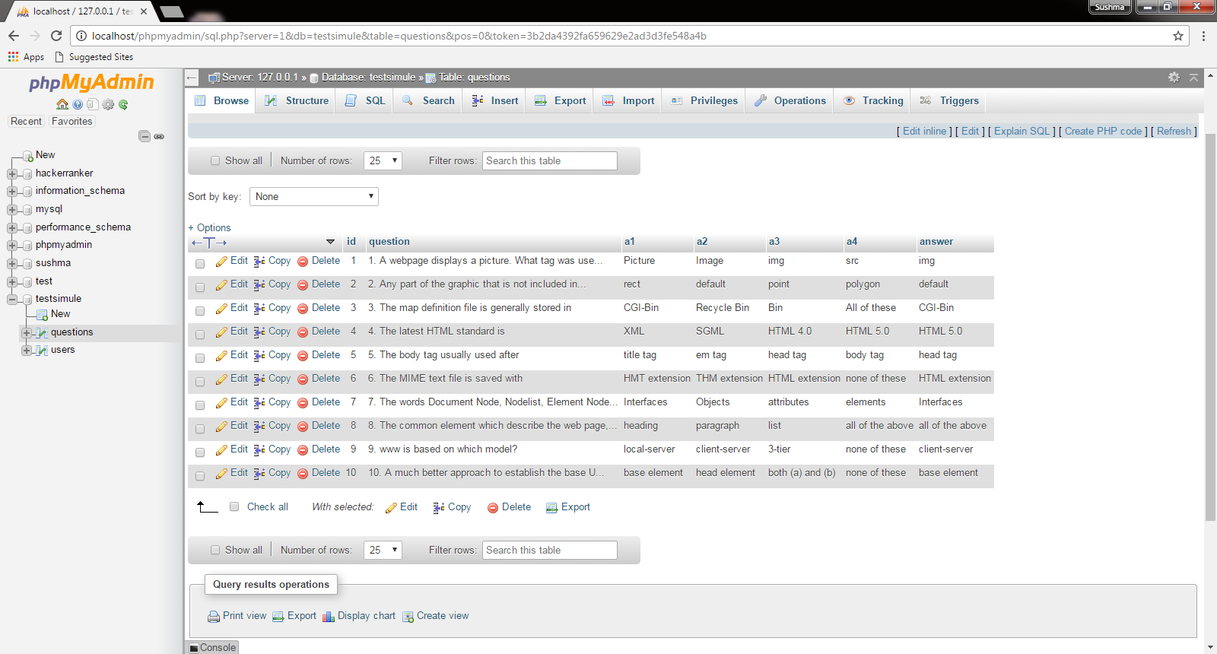

**Source code:**

<?php require_once('Connections/testsimule.php'); ?>

<?php

if (!function_exists("GetSQLValueString")) {

function GetSQLValueString($theValue, $theType, $theDefinedValue = "", $theNotDefinedValue = "")

{

if (PHP_VERSION < 6) {

$theValue = get_magic_quotes_gpc() ? stripslashes($theValue) : $theValue;

}

$theValue = function_exists("mysql_real_escape_string") ? mysql_real_escape_string($theValue) : mysql_escape_string($theValue);

switch ($theType) {

case "text":

$theValue = ($theValue != "") ? "'" . $theValue . "'" : "NULL";

break;

case "long":

case "int":

$theValue = ($theValue != "") ? intval($theValue) : "NULL";

break;

case "double":

$theValue = ($theValue != "") ? doubleval($theValue) : "NULL";

break;

case "date":

$theValue = ($theValue != "") ? "'" . $theValue . "'" : "NULL";

break;

case "defined":

$theValue = ($theValue != "") ? $theDefinedValue : $theNotDefinedValue;

break;

}

return $theValue;

}

}

$editFormAction = $_SERVER['PHP_SELF'];

if (isset($_SERVER['QUERY_STRING'])) {

$editFormAction .= "?" . htmlentities($_SERVER['QUERY_STRING']);

}

if ((isset($_POST["MM_insert"])) && ($_POST["MM_insert"] == "register")) {

$insertSQL = sprintf("INSERT INTO users (name, USN, Sem, Department) VALUES (%s, %s, %s, %s)",

GetSQLValueString($_POST['name'], "text"),

GetSQLValueString($_POST['USN'], "text"),

GetSQLValueString($_POST['Sem'], "int"),

GetSQLValueString($_POST['Department'], "text"));

mysql_select_db($database_testsimule, $testsimule);

$Result1 = mysql_query($insertSQL, $testsimule) or die(mysql_error());

$insertGoTo = "regsuccess.php";

if (isset($_SERVER['QUERY_STRING'])) {

$insertGoTo .= (strpos($insertGoTo, '?')) ? "&" : "?";

$insertGoTo .= $_SERVER['QUERY_STRING'];

}

header(sprintf("Location: %s", $insertGoTo));

}

$loginFormAction = $_SERVER['PHP_SELF'];

if (isset($_SERVER['QUERY_STRING'])) {

$editFormAction .= "?" . htmlentities($_SERVER['QUERY_STRING']);

}

if ((isset($_POST["MM_login"])) && ($_POST["MM_login"] == "login")) {

$insertSQL = sprintf("SELECT * FROM users WHERE USN = %s AND Sem = %s",

GetSQLValueString($_POST['USN'], "text"),

GetSQLValueString($_POST['Sem'], "int"));

mysql_select_db($database_testsimule, $testsimule);

$Result1 = mysql_query($insertSQL, $testsimule) or die(mysql_error());

$totalRows_Result = mysql_num_rows($Result1);

if ( $totalRows_Result > 0) {

$cookie_name="USN";

$cookie_value=$_POST['USN'];

setcookie($cookie_name,$cookie_value,time()+(86400*30),"/");

$insertGoTo = "questions.php";

if (isset($_SERVER['QUERY_STRING'])) {

$insertGoTo .= (strpos($insertGoTo, '?')) ? "&" : "?";

$insertGoTo .= $_SERVER['QUERY_STRING'];

}

header(sprintf("Location: %s", $insertGoTo));

} else {

$insertGoTo = "loginfailed.php";

if (isset($_SERVER['QUERY_STRING'])) {

$insertGoTo .= (strpos($insertGoTo, '?')) ? "&" : "?";

$insertGoTo .= $_SERVER['QUERY_STRING'];

}

header(sprintf("Location: %s", $insertGoTo));

}

}

mysql_select_db($database_testsimule, $testsimule);

$query_Insert = "SELECT * FROM users";

$Insert = mysql_query($query_Insert, $testsimule) or die(mysql_error());

$row_Insert = mysql_fetch_assoc($Insert);

$totalRows_Insert = mysql_num_rows($Insert);

?>

<!DOCTYPE html PUBLIC "-//W3C//DTD XHTML 1.0 Transitional//EN" "http://www.w3.org/TR/xhtml1/DTD/xhtml1-transitional.dtd">

<html xmlns="http://www.w3.org/1999/xhtml">

<head>

<meta http-equiv="Content-Type" content="text/html; charset=utf-8" />

<title>Home</title>

</head>

<!doctype html>

<!--[if lt IE 7]> <html class="ie6 oldie"> <![endif]-->

<!--[if IE 7]> <html class="ie7 oldie"> <![endif]-->

<!--[if IE 8]> <html class="ie8 oldie"> <![endif]-->

<!--[if gt IE 8]><!--> <html class="">

<!--<![endif]-->

<head>

<meta charset="utf-8">

<meta name="viewport" content="width=device-width, initial-scale=1">

<title>Untitled Document</title>

<link href="boilerplate.css" rel="stylesheet" type="text/css">

<link href="file:///C|/xampp/htdocs/testsimulation/testsimule.css" rel="stylesheet" type="text/css">

<link href="css/test.css" rel="stylesheet" type="text/css"/>

<script src="respond.min.js"></script>

</head>

<body>

<div class="gridContainer clearfix">

<div id="LayoutDiv1">

<div id="Holder">

<div id="HeaderContainer">

<div id="Header">

<h1>Test Simule!!</h1>

</div>

<div id="Nav">

</div>

</div>

<div id="Content">

<div id="ContentLeft">

<h1>Register</h1>

<form name="register" action="<?php echo $editFormAction; ?>" method="POST" id="register" style="margin:5px 0 0 20%">

<p><span>Name</span><input type="text" name="name" id="name" required placeholder="Ex: John Smith"/></p><br />

<p><span>USN</span><input type="text" name="USN" id="USN" required placeholder="Ex: 2BA14IS056" onchange="chkusn();"/></p><br />

<p><span>Semester</span><input type="text" name="Sem" id="Sem" required placeholder="Ex: 6" onchange="chksem();"/></p><br />

<p><span>Department</span><!--<input type="text" name="dept" id="dept" required="required" placeholder="Ex: ISE"/>-->

<select name="Department"><option value="AU">AU</option><option value="ISE">ISE</option><option value="CSE">CSE</option>

<option value="MECH">MECH</option><option value="CIVIL">CIVIL</option><option value="EEE">EEE</option>

<option value="ECE">ECE</option><option value="EI">EI</option>

<option value="BT">BT</option></select></p><br />

<p><span>&nbsp;</span><input type="submit" class="submit" name="submit" id="submit" value="Register"/></p>

<input type="hidden" name="MM_insert" value="register">

</form>

</div>

<div id="ContentRight">

<h1>Login</h1>

<form name="login" action="<?php echo $loginFormAction; ?>" method="POST" id="register" style="margin:5px 0 0 20%">

<p><span>USN</span><input type="text" name="USN" id="USN1" required placeholder="Ex: 2BA14IS056" onchange="chkusn1();"/></p><br />

<p><span>Semester</span><input type="text" name="Sem" id="Sem1" required placeholder="Ex: 6" onchange="chksem1();"/></p><br />

<p><span>&nbsp;</span><input type="submit" class="submit" name="submit" id="submit" value="Login"/></p>

<input type="hidden" name="MM_login" value="login">

</form>

</div>

</div>

<div id="Footer">

</div>

</div> </div></div>

<script src="js/valid.js"></script>

<script src="js/valid1.js"></script>

</body>

</html>

<?php

mysql_free_result($Insert);

?>

**Regsuccess,php:**

</head>

<body>

<div class="gridContainer clearfix">

<div id="LayoutDiv1">

<div id="Holder">

<div id="HeaderContainer">

<div id="Header">

<h1>Test Simule!!</h1>

</div>

<div id="Nav">

</div>

</div>

<div id="Content" style="padding-bottom:400px">

<h1>Registration Successful!</h1>

<p style="margin-left:45%">Click <a href="index.php"> here </a>to login</p>

</div>

<div id="Footer">

</div>

</div>

</div>

</div>

</body>

</html>

**Loginfailed.php:**

</head>

<body>

<div class="gridContainer clearfix">

<div id="LayoutDiv1">

<div id="Holder">

<div id="HeaderContainer">

<div id="Header">

<h1>Test Simule!!</h1>

</div>

<div id="Nav">

</div>

</div>

<div id="Content" style="padding-bottom:400px">

<h1>Login failed!</h1>

<p style="margin-left:45%">Click <a href="index.php"> here </a>to go back</p>

</div>

<div id="Footer">

</div>

</div>

</div>

</div>

</body>

</html>

**Questions.php:**

<script src="respond.min.js"></script>

</head>

<body>

<div class="gridContainer clearfix">

<div id="LayoutDiv1">

<div id="Holder" style="background-image:url(images/content1.jpg); background-repeat:repeat-y;">

<div id="HeaderContainer">

<div id="Header">

<h1>Test Simule!!</h1>

</div>

<div id="Nav">

</div>

</div>

<div id="Content">

<div id="Questions">

<form name="Questions" action="eval.php" method="post" >

<?php do { ?>

<p><?php echo $row_Questions['question']; ?></p>

<ul>

<li><input type="radio" name="<?php echo $row_Questions['id']; ?>" value="<?php echo $row_Questions['a1']; ?>"/><span><?php echo $row_Questions['a1']; ?></span></li>

<li><input type="radio" name="<?php echo $row_Questions['id']; ?>" value="<?php echo $row_Questions['a2']; ?>"/><span><?php echo $row_Questions['a2']; ?></span></li>

<li><input type="radio" name="<?php echo $row_Questions['id']; ?>" value="<?php echo $row_Questions['a3']; ?>"/><span><?php echo $row_Questions['a3']; ?></span></li>

<li><input type="radio" name="<?php echo $row_Questions['id']; ?>" value="<?php echo $row_Questions['a4']; ?>"/><span><?php echo $row_Questions['a4']; ?></span></li>

</ul>

<?php } while ($row_Questions = mysql_fetch_assoc($Questions)); ?>

**Eval.php:**

mysql_select_db($database_testsimule,$testsimule);

$total=0;

$cookie_name="USN";

foreach ($_POST as $param_name => $param_val) {

//echo "Param: $param_name; Value: $param_val<br />\n";

if ($param_name!="submit" || $param_name!="MM_submit")

{

$query_answer=sprintf("SELECT answer from questions where id=%s", GetSQLValueString($param_name,"int"));

$answer=mysql_query($query_answer,$testsimule) or die(mysql_error());

$row_answer=mysql_fetch_assoc($answer);

if(strcmp($row_answer['answer'],$param_val) == 0)

$total = $total + 1;

}

}

$value=$_COOKIE[$cookie_name];

$query_answer=sprintf("UPDATE users set marks=%s where USN=%s", GetSQLValueString ($total,"int"), GetSQLValueString($value,"text"));

$answer=mysql_query($query_answer,$testsimule) or die(mysql_error());

?>

**Conclusion:-**

It has been a matter of immense pleasure, honor and challenge to have this opportunity to take up this project and complete it successfully.

While developing this project we have learnt a lot about automation systems, we have also learnt how to make it user friendly hiding the complicated part of it from the users.

**References:-**